**Data Analysis of working hour and occupation choice**

1. Workinghour(ungrouped).png

See interactive plot (Workinghour(group)_income.html) at:

file:///Users/monicatao/Documents/ads/project1/workinghour(no group)_income.html

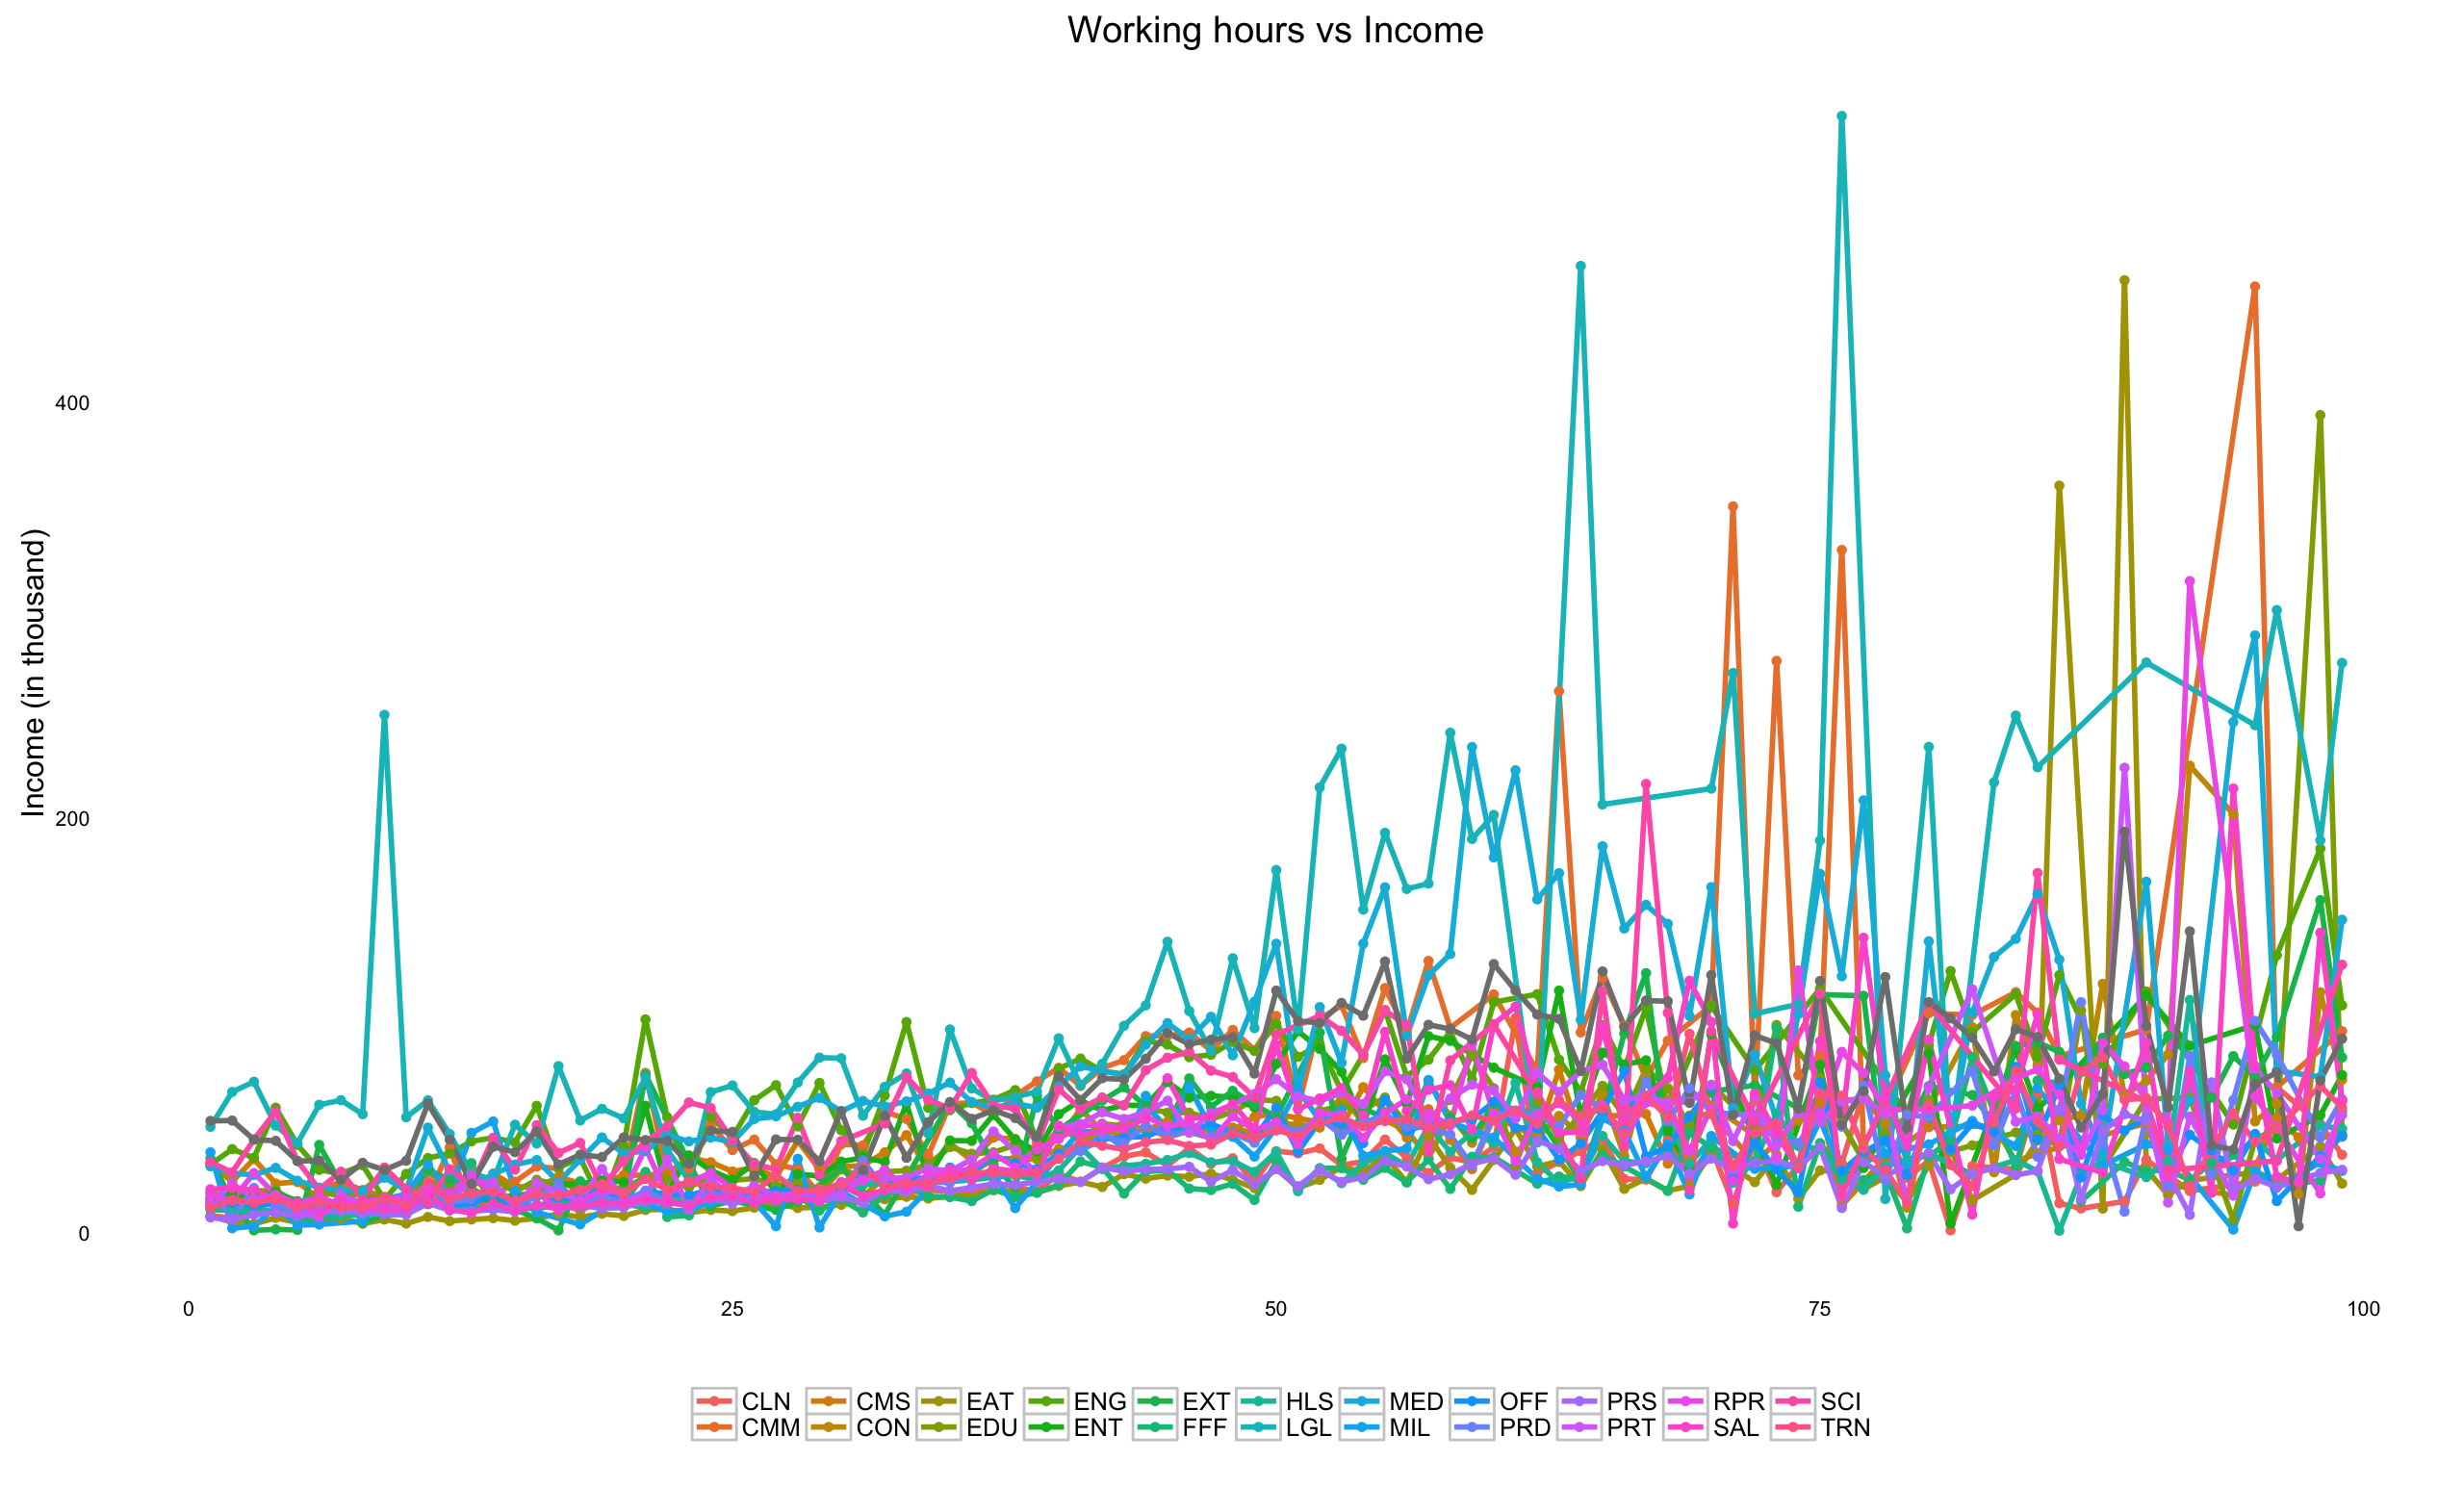

From the diagram, Income diverse a lot with long working hours while diverse only a little bit with short working hours.

1. Workinghour(grouped)_analysis.png

See interactive plot at:

<file:///Users/monicatao/Documents/ads/project1/workinghour(group)_income.html>

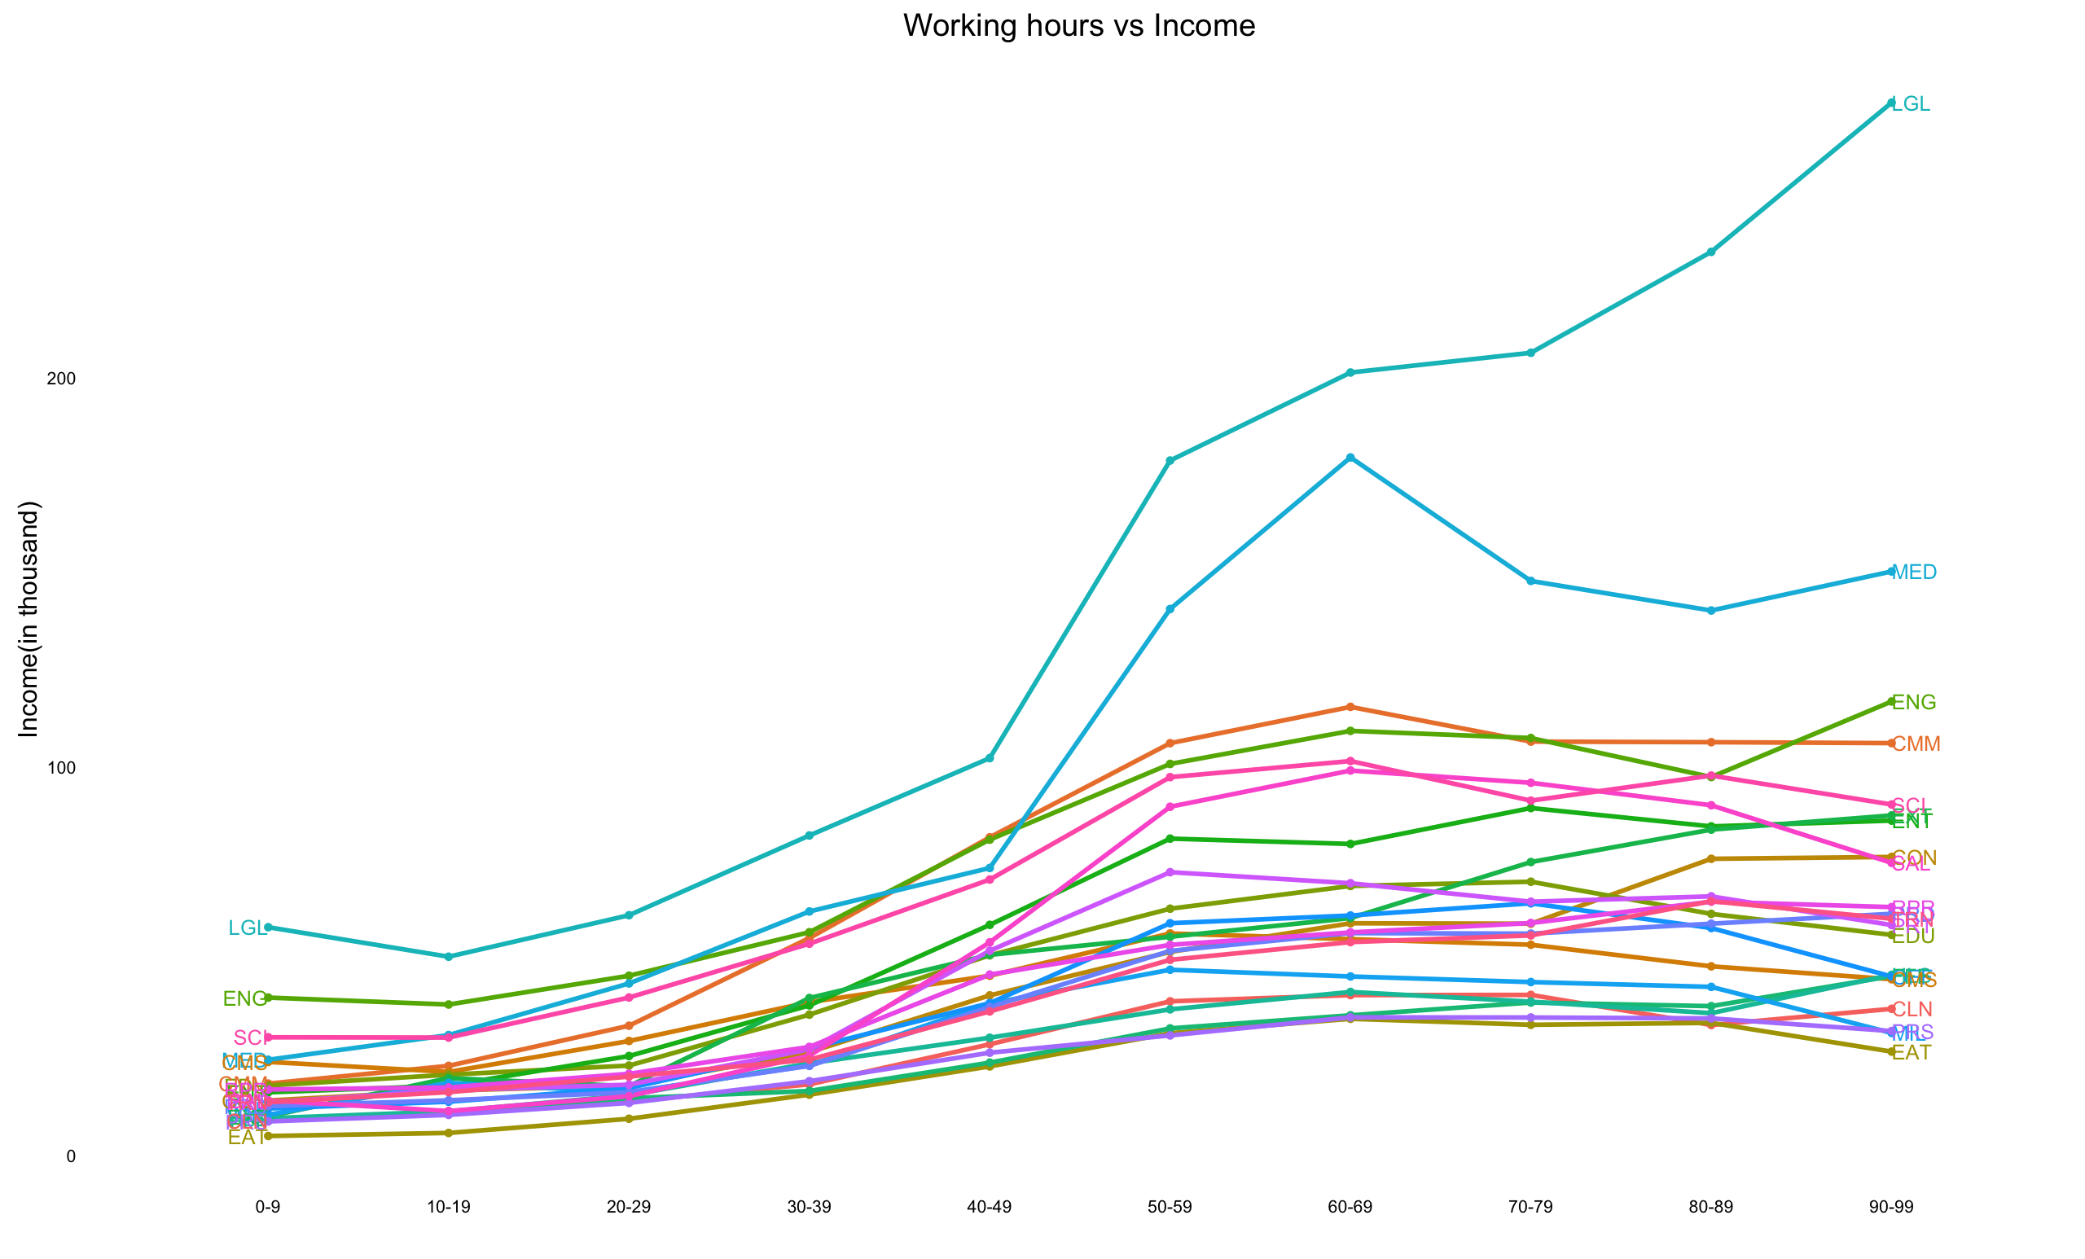

So the income is increasing with the working hours when you do not work so much, but as the working hours exceed 60 hours per week, the trend becomes unclear.

Also the trend of different occupation differs a lot. For example, for LGL-LAWYERS, AND JUDGES, MAGISTRATES, AND OTHER, it is increasing all the time, while for people work in medical area such as PHYSICIANS AND SURGEONS, the income is going down as working hours going up, this phenomenon also appears on many other occupations.

If you prefer regular working hour as 8 hours per day or 40 per week, then the top 5 choices of career are Lawyer, Computer programmer or developer, Engineer, Physician and Scientist.

If you are fine with long working hours, you can try to be a Lawyer or Derrick and Mining Machine worker.

Also, It seems that the higher-income jobs do not need you to work overtime while you need to work overtime with low-income job to earn higher income.

1. Income_by_workinghour(group).html

<file:///Users/monicatao/Documents/ads/project1/workinghour_income.html>

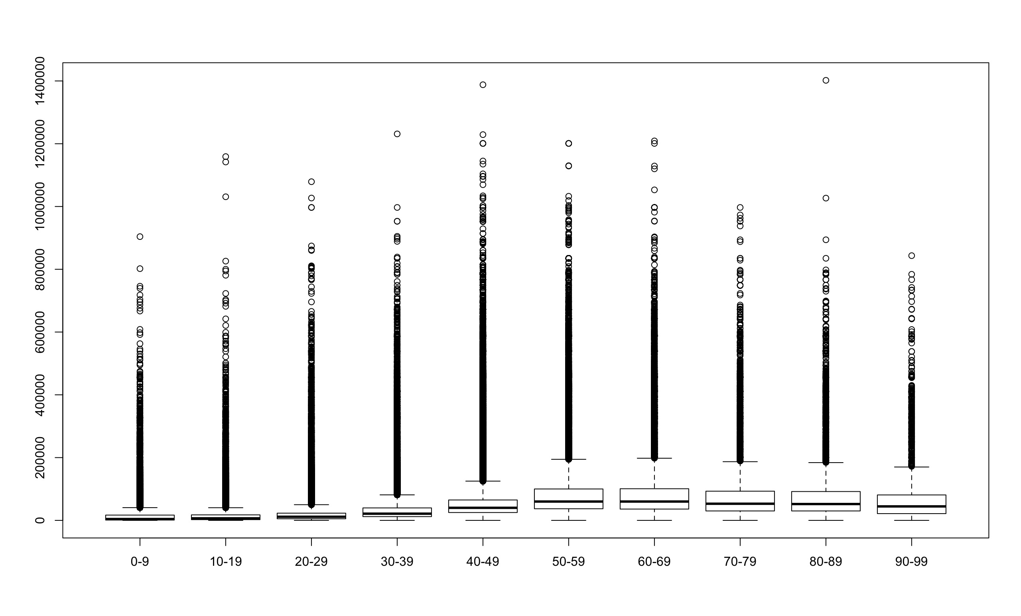

(This is just an simple plot inserted here for illustration.)

We can see after working hours exceed 60 hours, the income starts to decrease while working hour keep increasing.

1. Workinghour_by_occupation.html

<file:///Users/monicatao/Documents/ads/project1/workinghour_occupation2.html>

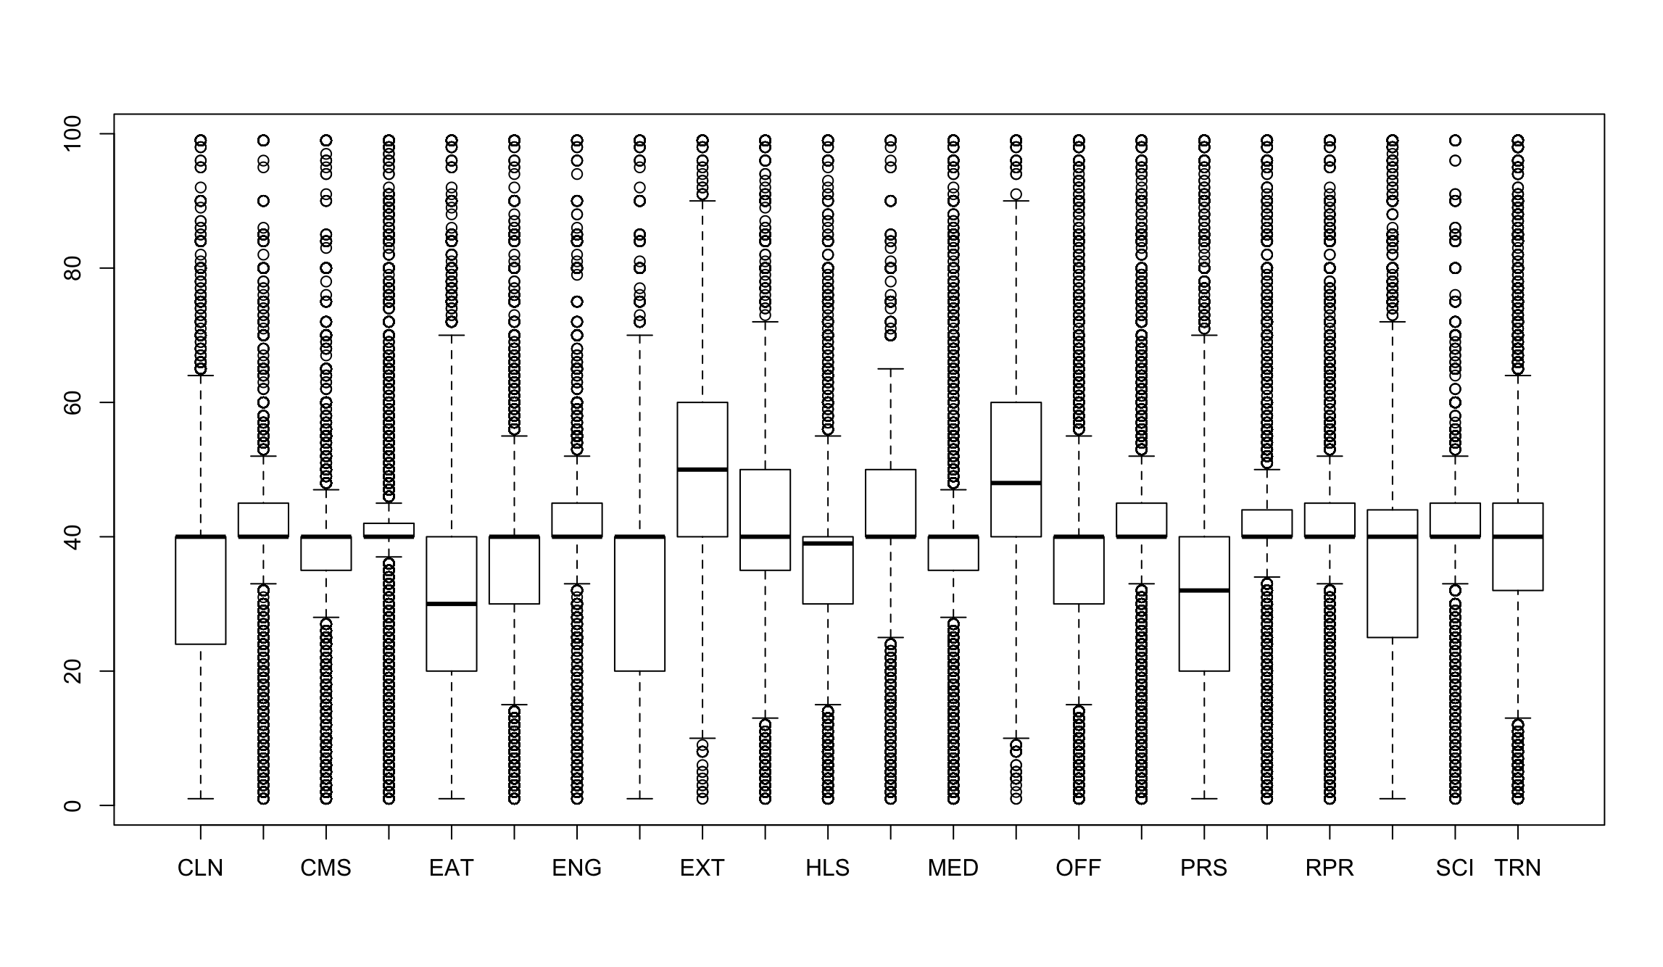

(This is just an simple plot inserted here for illustration.)

So the occupation with longest average working hour is Derrick and Mining Machine worker, followed by Military and Lawyer.

On the country, people working in restaurant works least such as cooks or food servers or dishwashers. Then comes people from other service industry, such as Fitness workers, Tour guides, Barbers, etc.

1. Workinghour_usmap.html

<file:///Users/monicatao/Documents/ads/project1/workinghour_usmap.html>

There are not so much difference of average working hour between different states. Alaska people work longer than others.